

COMPUTER GRAPHICS AND VISUALIZATION

**CS402.3**

**Coursework -2025**

**ROCK-PAPER-SCISSORS HAND GESTURE GAME**

|  |  |
| --- | --- |
| **Name** | **SID** |
| W P S Sandaruwan | 22807 |
| J M T P Devinda | 22804 |
| H M C S Henepola | 22792 |
| A C J D Silva | 22795 |
| A M C N Karandawala | 22798 |

**Group No – 15**

C O N T E N T S

01. Introduction

02. Image Processing Concepts Used

03. Testing Results

04. Why These Steps Were Used

05. Challenges Faced

06. Individual Contributions

07. Acknowledgement

01. I N T R O D U C T I O N

This project implements an interactive and engaging Rock-Paper-Scissors game that leverages real-time hand gesture recognition through a computer's webcam. By utilizing advanced computer vision techniques, the system captures and processes live video feed to detect and classify player gestures whether rock, paper, or scissors with high accuracy. The application not only facilitates a fun and competitive gaming experience but also provides real-time visual feedback on the image processing pipeline, offering users an educational glimpse into the underlying machine learning and computer vision algorithms that power gesture detection.

02. IMAGE PROCESSING CONCEPTS USED

**2.1 Grayscale Conversion**

**What ?**

Converts the BGR image to grayscale using OpenCV.

**Why?**

Simplifies the image and reduces complexity before thresholding.

Screenshot:

**2.2 Thresholding**

**What ?**

Converts grayscale to a binary image using a fixed threshold value.

**Why ?**

Helps isolate the hand from the background.

Screenshot:

**2.3 Contour Detection**

**What ?**

Finds boundaries of white blobs (i.e., hand) in the thresholded image.

**Why ?**

Visualizes the shape of the hand and gesture.

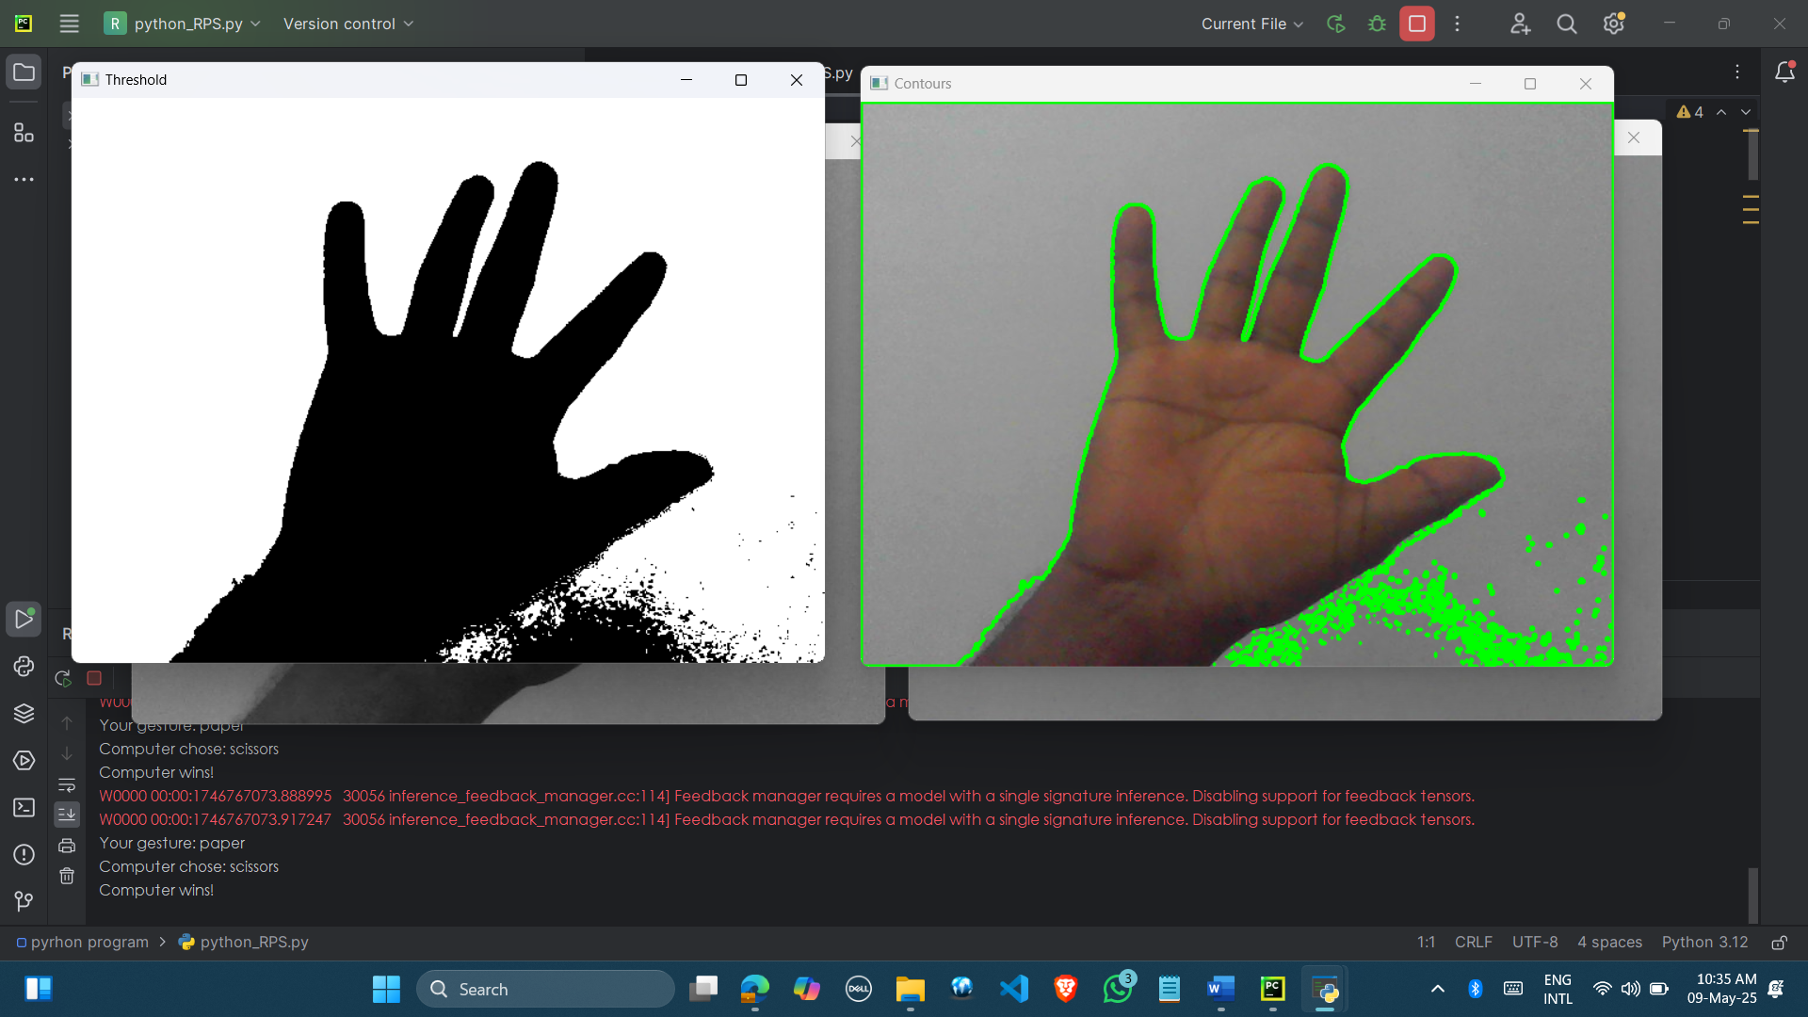Screenshot:

**2.4 Hand Landmark Detection (Media Pipe)**

**What ?**

Identifies 21 hand landmarks using Google’s Media Pipe.

**Why ?**

Allows us to analyze finger positions to classify gestures.

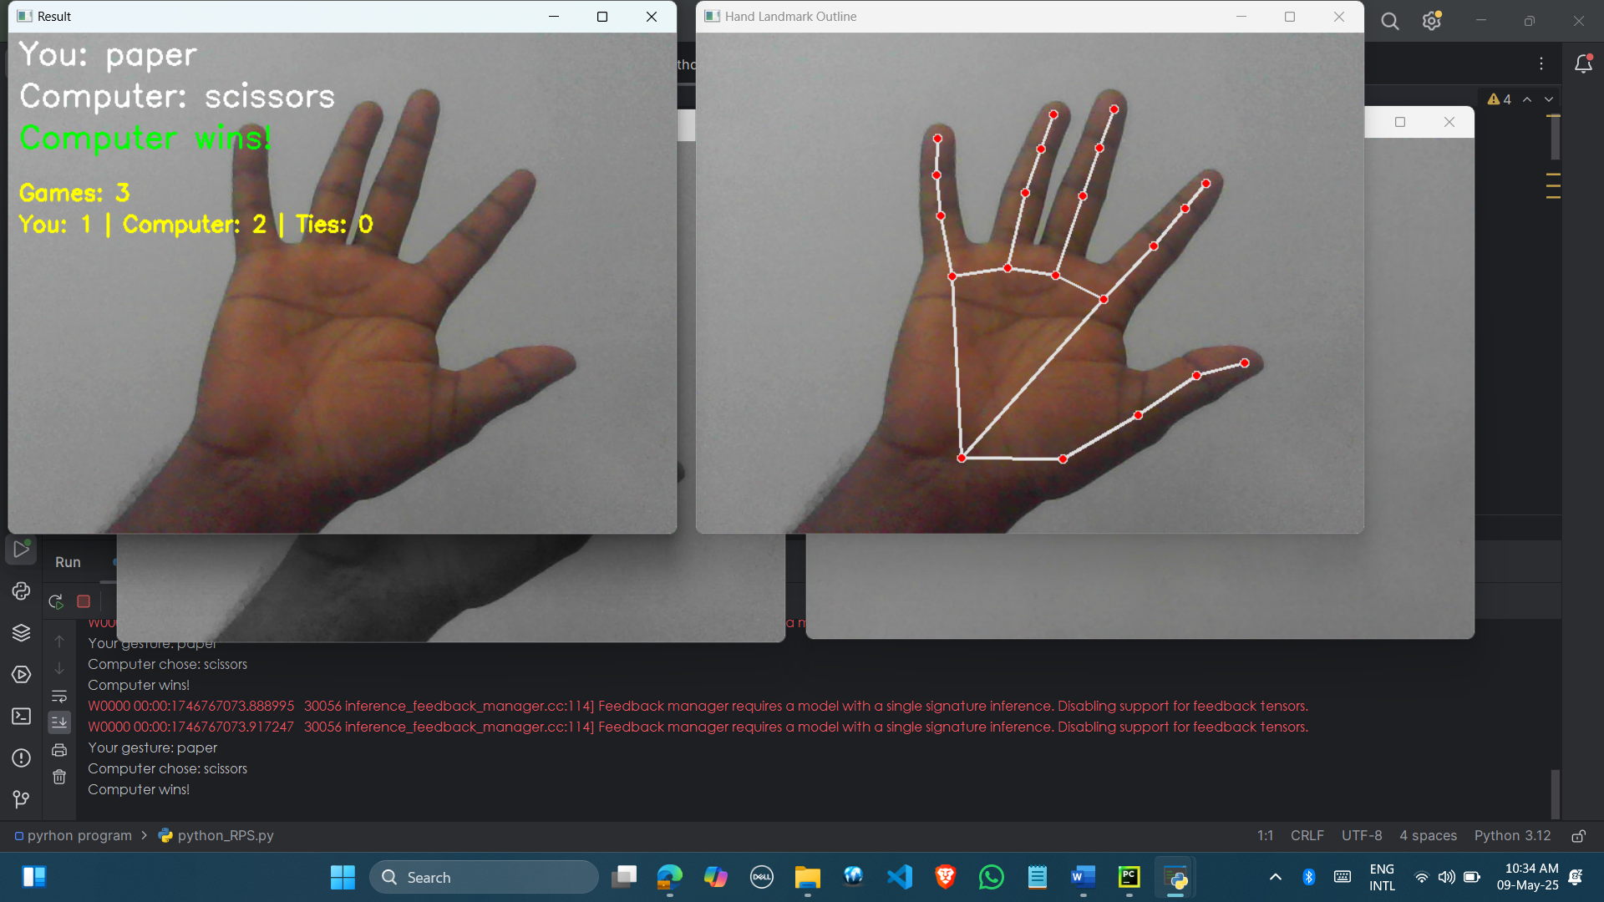Screenshot:

03. T E S T I N G R E S U L T S

**3.1 Input: Rock Gesture**

✅ Correctly classified as **Rock**

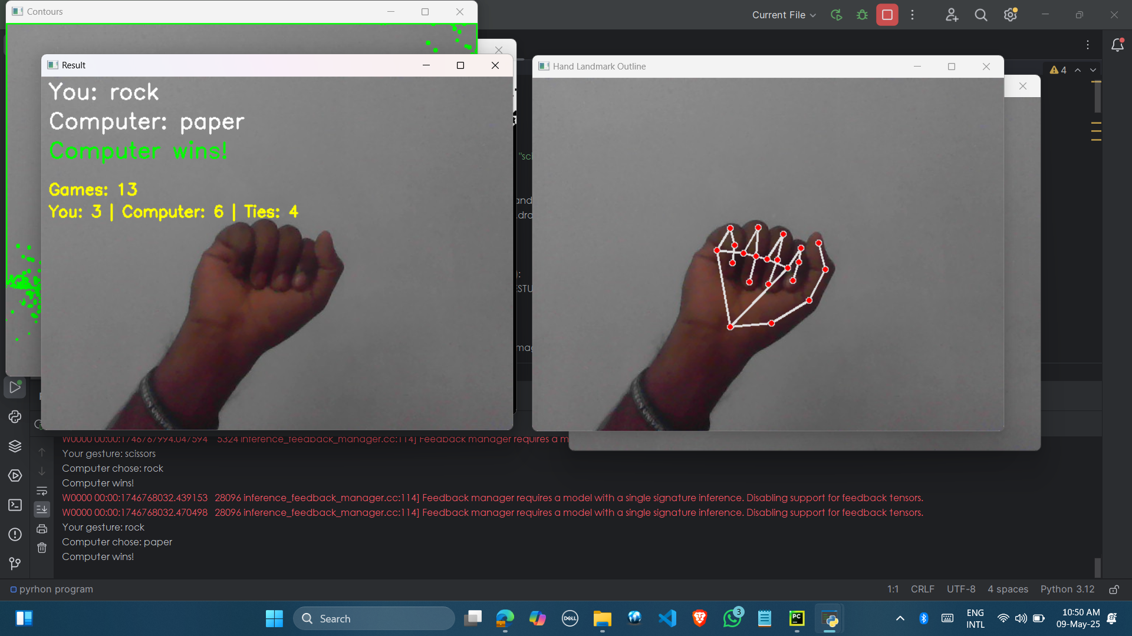Screenshot:

**3.2 Input: Paper Gesture**

✅ Correctly classified as **Paper**

  
Screenshot

**3.3 Input: Scissors Gesture**

✅ Correctly classified as **Scissors**

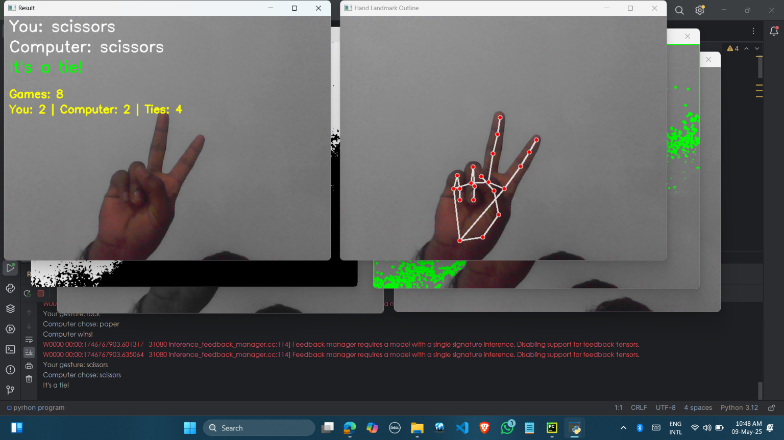

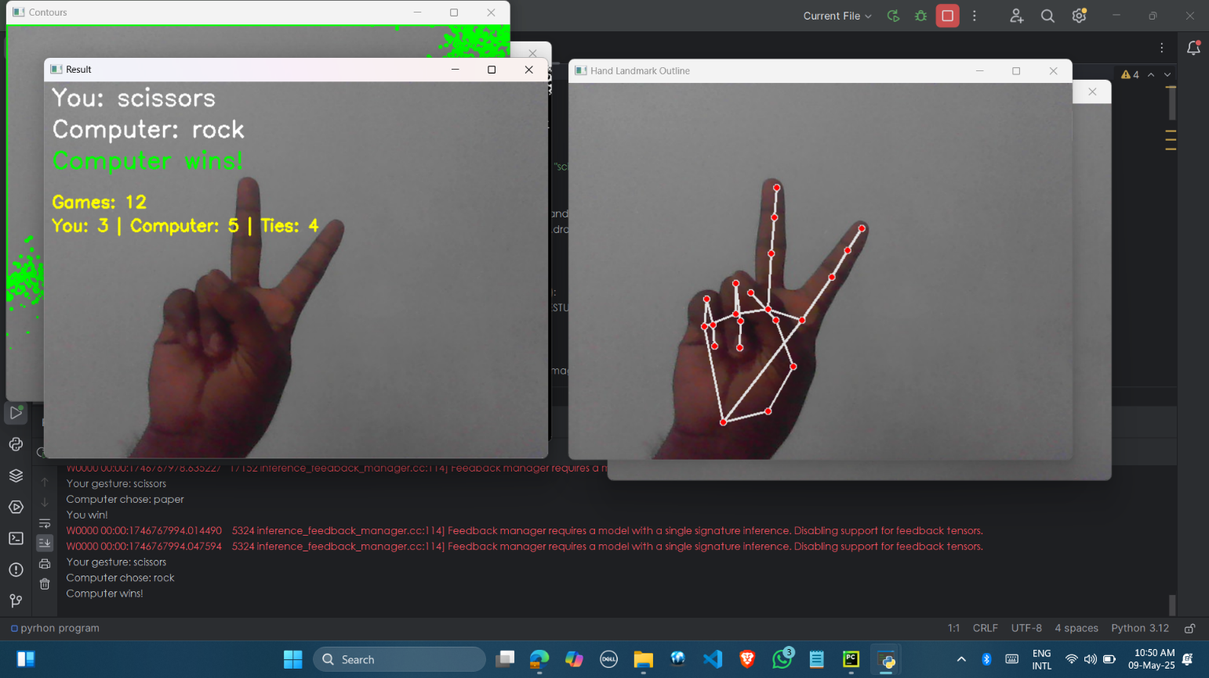

04. WHY THESE STEPS WERE USED

* Grayscale simplifies processing by removing color noise.
* Thresholding helps separate hand from the background clearly.
* Contours provide visual feedback on hand shape.
* Media Pipe provides high-accuracy, real-time hand landmark detection.
* Combined, these steps enable accurate, real-time gesture classification.

05. C H A L L E N G E S F A C E D

* Hand recognition fails under poor lighting conditions.
* Similar gestures (e.g., one-finger vs. two-finger) are hard to separate.
* Background clutter affects contour detection.
* Media pipe performance varies on low-end hardware.
* Difficulty in detecting the thumb position reliably.

|  |  |  |  |
| --- | --- | --- | --- |
| **Member Name** | **SID** | **Role** | **Contribution Summary** |
| W P S Sandaruwan | 22807 | Developer & Integrator | Main game flow, integration of modules, UI elements |
| J M T P Devinda | 22804 | Image Processing Lead | Grayscale, thresholding, contour visualization |
| A C J D Silva | 22795 | Media Pipe Specialist | Hand gesture classification logic |
| H M C S Henepola | 22792 | Game Logic Developer | Winner decision logic, random computer move, test cases |
| A M C N Karandawala | 22798 | Documentation & Testing | Screenshots, testing scenarios, written documentation, image annotation |

06. I N D I V I D U A L C O N T R I B U T I O N S

07. ACKNOWLEDGEMENT

We would like to extend our heartfelt gratitude to **Dr. Rasika Ranaweera**, our respected lecturer for the **Computer Graphics and Visualization** module, for his unwavering support, guidance, and encouragement throughout our academic journey.

His insightful lectures and deep knowledge in the field of computer graphics have greatly enhanced our understanding and inspired us to explore practical applications, such as this hand gesture recognition game. The clarity and depth of his teaching enabled us to confidently apply image processing and visualization concepts in our project.

We are truly grateful for his mentorship and for fostering an environment of innovation and critical thinking, which contributed immensely to the successful completion of this work.

********************* Thank You **********************